4-H Online 2.0 Volunteer Renewal Guide

New Enrollment
Join over 11,000 adults committed to youth across Colorado by joining the Colorado 4-H youth development program! How do you become a 4-H leader? Contact your county office to learn more! The safety of 4-H members is paramount. You will be asked to fill out an application and undergo a national background and motor vehicle check in order to become a volunteer. Volunteer Resources can be found on the Colorado 4-H website as well.

Re-enrollments
Log into co.4honline.com.
- Enter the email address and password you used previously, then click “Sign in.”
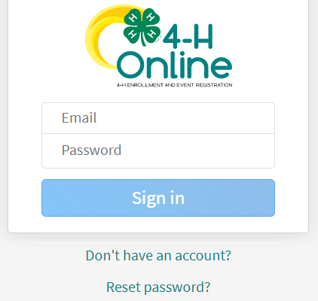
  - Forgot your password? Scroll below the “Sign in” button and click “Reset password.” A temporary password will be sent to the email address associated with your account. You will be prompted to change this to a permanent password.
  - Not sure which email address you used? Contact your local staff to ask them to look it up.
  - Problems with your password? 4HOnline 2.0 has higher password standards, so it’s possible that your password is too short or requires additional security. Contact your local staff.
- Click on “Member List” to see a list of youth and adults in your family account.
- Select your name, then click “Enroll Now.”
- When you see “I’m confirming I want to enroll in 4-H as a Volunteer,” click “Enroll.”
- Select Volunteer Type(s). You may select 1 or more of the following 3 types:
  - Club – allows you to select a club.
    - 4-H Club Adult Volunteer = a general volunteer in your club.
    - 4-H Club Contact Leader = if you are the main leader of your club.
  - Project – allows you to select projects, especially useful if you help with this project at the county level or if you want to receive project-specific emails about this project.
- Select Units (clubs or groups):
  - This will only appear if you selected the Club volunteer type.
  - Find club name and click “Add.”
  - Click “Next.”
- Select Projects
  - This will only appear if you selected the Project volunteer type.
  - Select whether you work on this project (or would like to) at the county or club level.
  - Select the project and click “Add.”
  - Click “Next” when finished adding projects.
- About You
  - Click “Show Questions.”
  - Review data that is carried over and fill in any blank required fields.
  - Click “Next” when done.
- Review Consents. This is the same information that was on your original application as a new volunteer.
  - Type your full name and click “Agree.”
  - Click “Next.”
- Click “Submit,” then “Confirm.”
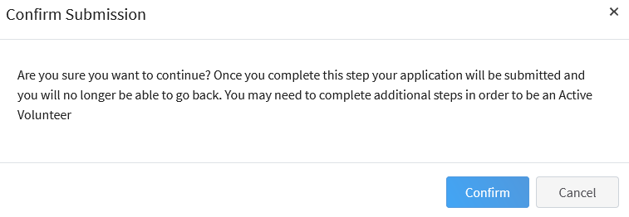
  - You will receive an email confirmation that your enrollment has been submitted.
  - Additional Information will be needed once the initial enrollment has been submitted.

- Click “Show Screening” – REQUIRED to Re-enroll for this year ONLY!
  - Type ‘n/a’ under “Other Names”
  - Scroll to the bottom of the page and sign and agree with the statement ONLY.
Background checks will ONLY be completed on NEW volunteers or non-active status is greater 12 months. Click “Submit”
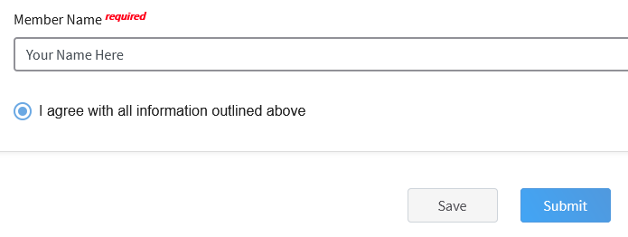
- You will receive an email from 4-H Online with a confirmation. Please allows for several business days for final approval. Should you have any questions please contact your local extension staff directly.

