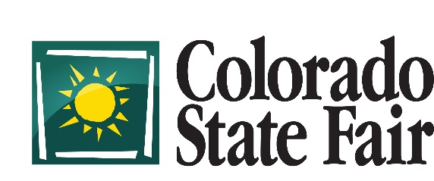
Livestock Department, 1001 Beulah Ave., Pueblo, CO 81004
719-404-2035

To: Colorado County 4H Agents/ FFA Program Instructors

From: Robyn Toft, Livestock Events Coordinator

Date: May 7, 2019

Attached are forms for nomination of Market Rabbit Pens, Market Chicken Pens, and Market Turkeys for the 2019 Colorado State Fair. Feel free to email me or call 719-404-2035 with questions. These Nomination forms need to be to the Extension Offices by July 6th and postmarked to the Colorado State Fair Small Animal Office by July 13th. Exhibitors may nominate as many as they would like, however, only four (4) pens or turkeys may be brought to the Fair. No late nominations will be accepted.

Please instruct your exhibitors that birds and rabbits NOT nominated will not be eligible to show at the Colorado State Fair and entries will be returned to the exhibitor (no exceptions).

Market Rabbits all need to be born around June 15th in order to be the correct age to compete in the Market Rabbit division of the fair. Market Rabbits cannot be older than 10 weeks on the day of show (August 24, 2019) and weigh between 3.5 and 5.5 pounds.

Market chickens must be hatched around July 13th and be no older than 6 weeks old at the time of show.

Fryers must be no less than 8 weeks old and broilers no less than 20 weeks old.

The age requirements for Market Turkeys will be 14 weeks for hens and 18 weeks for toms. Hen turkeys must weigh a minimum of 14 lbs. to show and toms must weigh a minimum of 16 lbs. to show. Both toms and hens are eligible. No turkey weighing over 30 lbs. will be allowed to show in the market division.

For identification, the exhibitor would need to decide what the tattoos were going to be for the rabbit pen and list 4 of them on the nomination form. As for the Market Chickens, the exhibitor would need to list 4 leg band numbers per Market Pen. These tattoos and leg bands will not need to be in or on the animal(s) until arrival at the fair.

Please advise the Small Animal exhibitors in your county that they will be required to participate in a Meat Quality Assurance program and sign a “Quality Assurance” form to turn in at the time of weigh-in. Full disclosure of any medications, medicated feeds and/or supplements given to animals exhibited at the Colorado State Fair is required on this form. Exhibitors who have not completed a Meat Quality Assurance Program (either Colorado MQA or YQCA) are not eligible to show at the Colorado State Fair.

Exhibitors MUST provide Premises ID (PID) on nomination and entry forms, forms without PID will be rejected and returned (no exception).

You may make as many copies of the form(s) as necessary. We sincerely appreciate your work in getting all of your County Rabbit, Chicken, and Turkey project exhibitors properly signed up.

